ECE 206 Lab 8: Op-Amps
Lab Performed By: Derek Kwok & Vikram Shah
On: April 2, 2014
Report Date: April 6, 2014
Statement of Purpose:
Build a two-stage, controllable-gain amplifier. It should consist of a high-impedance buffer stage followed by a variable gain stage controlled by a potentiometer, both operating from a single-ended supply voltage (your 9V battery). The amplifier should have enough potential gain to be able to produce a distortion effect on a typical audio-band input signal, similar to how distortion pedals are used for electric guitars.
Plan: 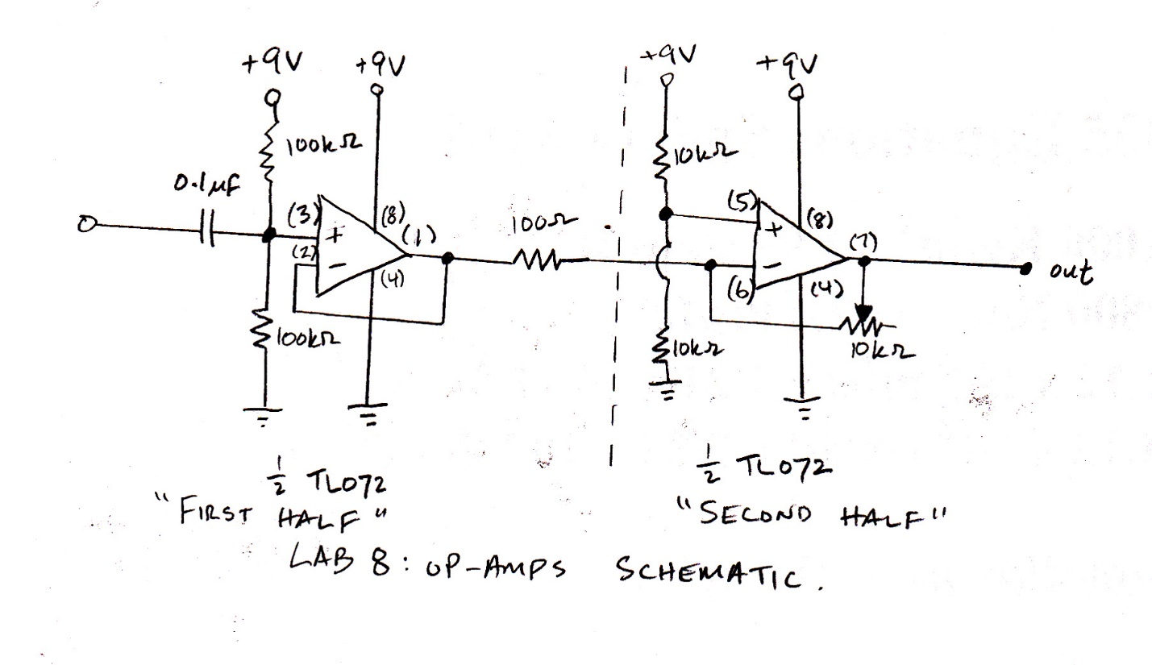
Circuit Diagram
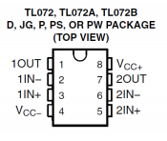
TL072 package pinout diagram
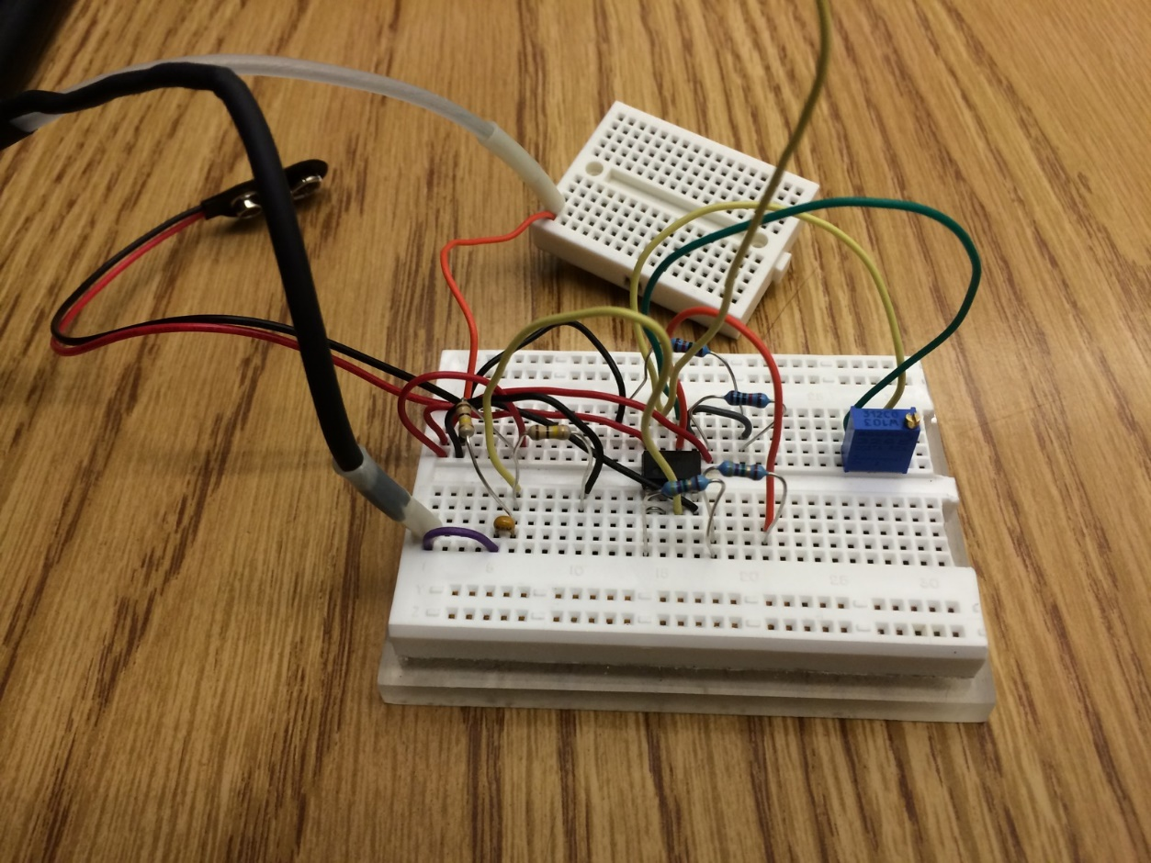
Actual Circuit
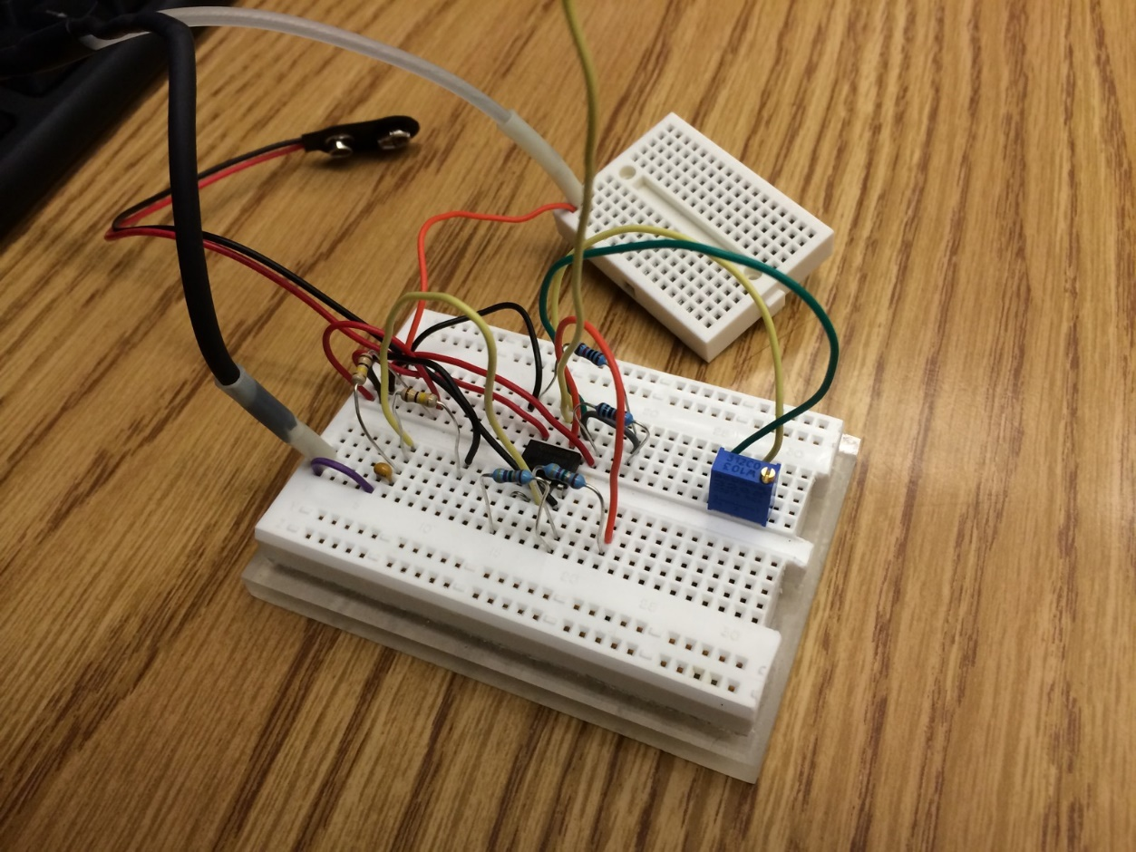

Execution:
The first order of business was building our op-amp circuit; since it was the most complex circuit we had built to date, though, we built the first “half” of the circuit (the input buffer stage), tested it with the oscilloscope and function generator, and then completed the circuit (inserted the gain stage component) and performed the remaining analysis.
When connecting the function generator, we set it to 100mVpp, 440 Hz by using the frequency and amplitude settings on the control panel, and we also set the function generator into High Impedance (“HIGH-Z”) mode. The following is the procedure used to get into high impedance mode:
- Press Shift-Enter (Menu On)
- Press right arrow key 3 times (SYS MENU)
- Press down arrow key 2 times
- Press right arrow key (HIGH Z)
- Press Enter
After completing the first half of the circuit, we hooked up the oscilloscope to the circuit at the output pin of the first op-amp (pin 1 of the TL072 IC), and observed the waveform as identical to the waveform output by the function generator, as expected:
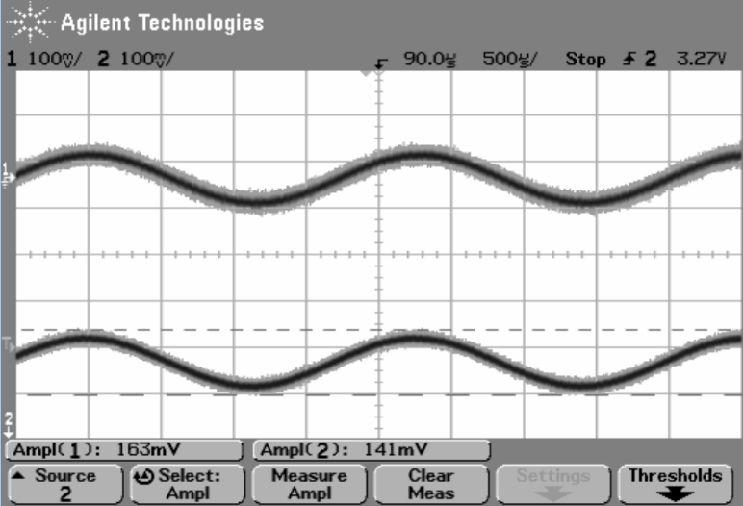
Upon completion of the total circuit, we connected the oscilloscope to the output pin of the second op-amp (pin 7 of the TL072 IC) and observed the unclipped and clipped waveforms, by tuning the trimpot. As we increased the amplitude of the waveform, clipping gradually became apparent. Screenshots of the waveforms can be viewed below.
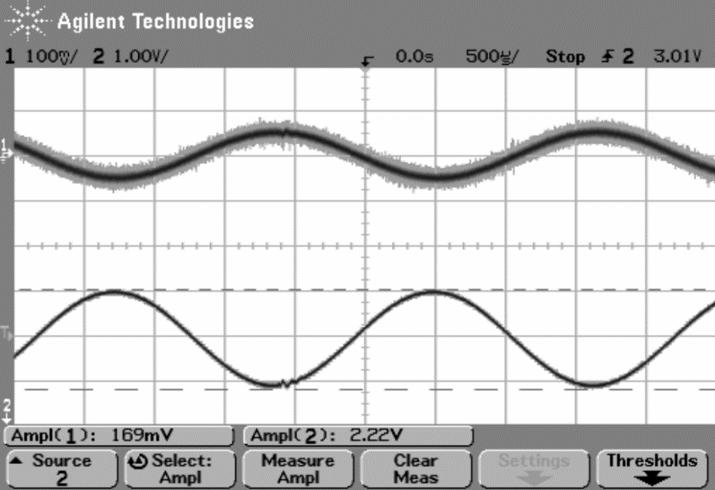
Unclipped Waveform (smooth)
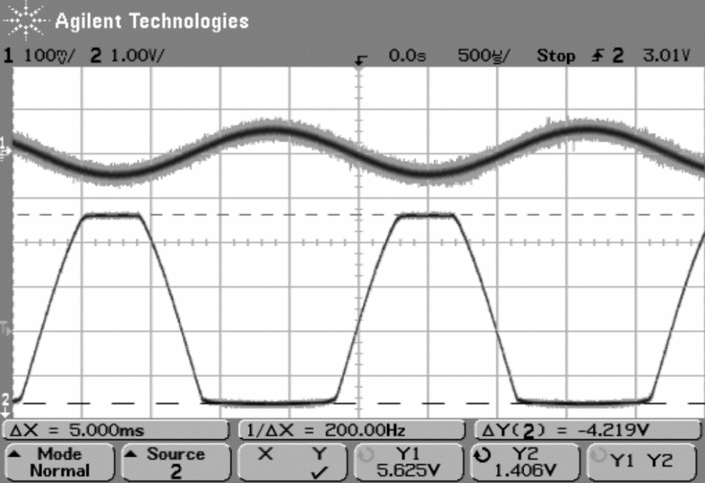
Clipped Waveform (high and low frequencies “clipped” off)
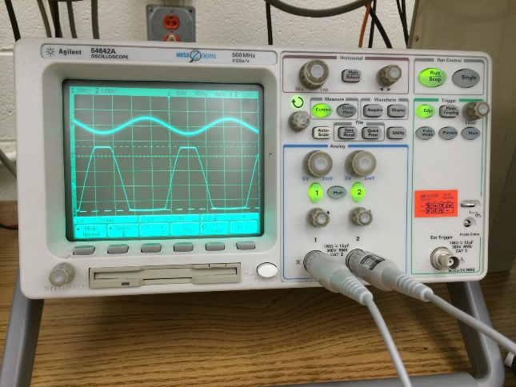
Oscilloscope: Clipped Waveform
After we analyzed the waveforms in the oscilloscope, we connected a speaker to the output of the second op-amp (pin 7 of TL072 IC) and listened to the unclipped and clipped waveforms. The clipped waves were notably less rich, but also louder, while the unclipped waveforms were softer and more full-sounding and resonant.
Results
Screen captures: shown above.
Ratio of amplitudes for input buffer stage: 163/141 = 1.16.
This is approximately 1, which makes sense because the buffer does not change amplitude. The voltage that goes in is the same that comes out.
Maximum/minimum clipped waveform voltages: 5.625 V / 1.406 V
Role of the input biasing network:
When the op-amp is being driven by a DC source, the behavior is linear, but when driven by an AC source such as the function generator, the output oscillates about the “bias point.” Because we don’t want the op-amp to distort, i.e. leave the linear region of operation and saturate (go beyond the power supply limitations), we use the input biasing network to steady the oscillation.
Conclusions
- Purpose of the input biasing network: above.
- Purpose of the unity gain buffer: The buffer makes the load behave like an ideal voltage source, which reduces power consumption, interference, and artifacts that would detract from the purity of the signal.
- Clipping occurs when the amplitude of the output signal exceeds the limitations on the max output of the op-amp. This max output is determined mainly by the power supply rails; in our case, the power supply was at +9V and 0V; the max and min clipped voltages were 5.625V and 1.046V, meaning that any information beyond those voltages was lost in amplification through the op-amp.
- When the sound is clipped, the smoothness of the waveform is lost, and the result is that variations in volume are lost. All sounds become equally loud when clipped extremely, and extra harmonics appear as a result.

